MONEYPAD - THE FUTURE WALLET

- Srishti Sharma, Bharati Vidyapeeth College of Engineering

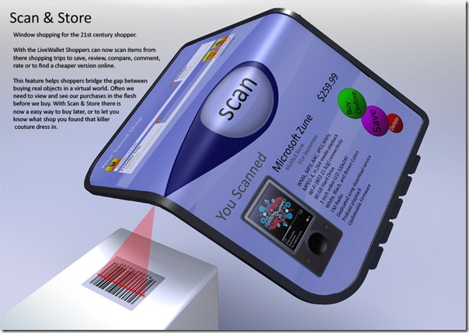

The 21st century will not be cashless, as many people predict today. However, it does seem clear that the currency of 21st century will be “paperless”. Just as everything is getting under the shadow of “e”. Today we have paper currency being replaced by electronic money or e-cash in the form of MoneyPads.

The use of technology in commercial activities for many years has led to the emergence of various new supporting services in the marketplace. Among these services is the e-payment which enables payment done via the electronic medium and without involving any physical cash. Paper currency and checks are gradually substituted by smart cards, digital cash, and instant transfer of funds.

The wallet of the future will hold less paper cash, coins and magnetic stripe cards. It will hold instead MoneyPad containing digital cash and other financial information.

The money pad here uses the biometrics technology for finger print recognition. MoneyPad is the form of credit card or smart card. It consists of a touch sensor and magnetic disk as its peripherals. Touch sensor is used to record the fingerprint of the user. Magnetic disk, which has the read and write permission is used to hold the authentication details of the user, bank code as well as digital-cash. The bank code and account number of the owner of this money pad is present on the label. Every time the user wants to access the moneypad he has to make an impression of his fingers which will be scanned and matched with one in the hard disk of the data base server. If the finger print matches with the user’s he will be allowed the access and use the Pad otherwise the money pad is not accessible.

Although credit cards provide us with e-cash but it offers some disadvantages. In credit cards user is always under the pressure of limits on purchase defined by the issuer of the card and  
also every transaction involves certain charges. Credit card uses fixed encryption hence, the transactions are insecure. Also the card has to be renewed once it is expired.

For a digital currency system to attain widespread recognition and use, the following three requirements are necessary. These are: instant clearing of funds, elimination of payment risk and secure transactions using strong encryption. MoneyPad fulfills all such requirements and offers many advantages. It reduces fraud by employing hard to forge technologies and materials. It eliminates the problems caused by loss of IDs or forgotten passwords by using physiological attributes. It also makes it possible to know WHO did WHAT, WHERE and WHEN.

Money platform uses the most secure encryption and decryption methods for online transactions money platform allows the instant release of funds, and it acts as a digital cash. This avoids the inconvenience of extension, and can be used in Trade and implement remote transactions in a simpler way.

In the future when we will have the ‘Internet Of Things’ there would be a decreasing requirement of any cards or pads just small devices which would be able to identify finger prints and could be found all over the world.